Q1:

Given 4 memory partition of 600k, 619k, 250k, 500k Now we have to allocate the process of size 128k, 581k, 411k, 221k respectively

First Fit:-

Memory Size Memory Partition

128 600 k

581 619 k

221 250 k

411 500 k

Best Fit:-

Memory Size Memory Partition

581 600 k

221 619 k

128 250 k

411 500 k

Worst Fit:-

Memory Size Memory Partition

581 600 k

128 619 k

221 250 k

411 500 k

Observations:

best fit is better than first fit

first fit is better than worst fit

best fit > first fit > worst fit

Q4:

**Data:**

Size Of Physical Memory: 239

Size Of Pages: 211

Number Of Pages in logical address space: 223

Formula:

**Number of bytes in logical address = Pages in logical address x Page Size**

**(a)**

=> 223 x 211

=> 234 bytes **Ans.**

**Hence, the number of bits in logical address is 34.**

**(b)**

The size of the frame is same as the size of the pages: 211 bytes**Ans.**

* The memory in the physical memory is divided into fixed sized blocks called pages frames
* Each process in the logical memory is divided into fixed size chunks called pages
* The pages are assigned to available fixed sized blocks called page frames.

**(c)**

The number of frames in physical memory is calculated as follows:

Number of frames = Size Of Physical Memory

Size Of Page Frame

Number Of Frames = 239

211

Number Of Frames = 228

**Therefore, the number of bits required to specify the frame location in physical memory is 28. Ans**

The number of entries in the page table is the number of pages in the virtual memory therefore the number of entries in the page table is 223 **Ans.**

Q3:

3(A)

A single threaded process can only run on one CPU, whereas the execution of a multi-threaded application may be split amongst available processors. single kernel thread can operate only on a single CPU, the many-to-one model does not allow individual processes to be split across multiple CPUs.

3(B)

Thread switching is a type of context switching from one thread to another thread in the same process. Thread switching is very efficient and much cheaper because it involves switching out only identities and resources such as the program counter, registers and stack pointers.

3(C)

observation:

1-Offloading a batch of work to a worker thread so your program can either continue responding to user input or so you can carry on running other code that doesn't rely on that work.

2- Handling INPUT/OUTPUT particularly server and network communication where the response time is variable or unknown.

3- Parallel processing of data where you can sub-divide the work down into discrete non-dependent units of work

4. Timer related work that is very 500ms check if x has changed

However, switching to multi-threaded or concurrent programming is not without it's

pitfalls particularly if those threads need to access shared data.

Q2:

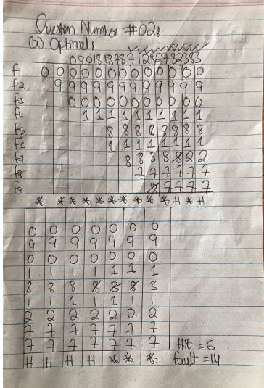

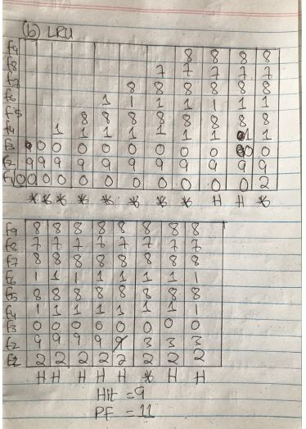

Q5:

(a)

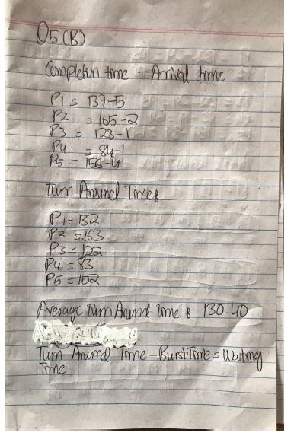

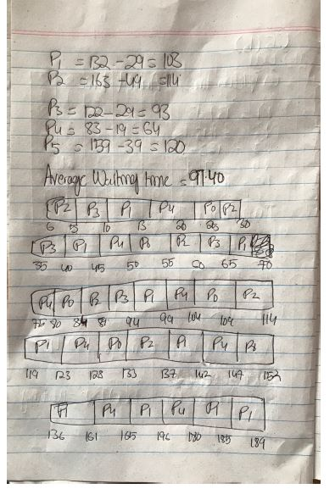

(b)

#include<stdio.h>

void main()

{

int n,i,j,TEMP,TEMP1,TEMP2,TEMP3,TEMP4;

float WTSUM=0,TATSUM=0;

int bt[10],at[10],P[10],ct[10],tat[10],wt[10],pt[10];

printf("enter the no of process\n");

scanf("%d",&n);

for(i=1;i<=n;i++)

{

printf("Enter the arrival time of p%d:\t",i);

scanf("%d",&at[i]);

printf("Enter burst time of p%d: \t",i);

scanf("%d",&bt[i]);

printf("Enter the priority :\t");

scanf("%d",&pt[i]);

P[i]=i;

printf("\n");

}

ct[0]=0;

if(bt[1]>=at[n])

{

ct[1]=bt[1]+at[1];

tat[1]=ct[1]-at[1];

wt[1]=tat[1]-bt[1];

WTSUM=wt[1];

TATSUM=tat[1];

for(i=2;i<=n;i++)

{

for(j=i+1;j<=n;j++)

{

if(pt[j]<pt[i])

{

TEMP4=pt[i];

pt[i]=pt[j];

pt[j]=TEMP4;

TEMP1=bt[i];

bt[i]=bt[j];

bt[j]=TEMP1;

TEMP2=at[i];

at[i]=at[j];

at[j]=TEMP2;

TEMP3=P[i];

P[i]=P[j];

P[j]=TEMP3;

}

}

if(ct[i-1]<at[i])

{

TEMP=at[i]-ct[i-1];

ct[i]=ct[i-1]+bt[i]+TEMP;

TEMP1=bt[i];

}

else

{

ct[i]=ct[i-1]+bt[i];

}

tat[i]=ct[i]-at[i];

wt[i]=tat[i]-bt[i];

WTSUM=WTSUM+wt[i]+wt[1];

TATSUM=TATSUM+tat[i]+tat[1];

}

}

if(at[n]==0)

{

ct[0]=0;

for(i=1;i<=n;i++)

{

for(j=i+1;j<=n;j++)

{

if(pt[j]<pt[i])

{

TEMP4=pt[i];

pt[i]=pt[j];

pt[j]=TEMP4;

TEMP1=bt[i];

bt[i]=bt[j];

bt[j]=TEMP1;

TEMP2=at[i];

at[i]=at[j];

at[j]=TEMP2;

}

}

if(ct[i-1]<at[i])

{

TEMP=at[i]-ct[i-1];

ct[i]=ct[i-1]+bt[i]+TEMP;

TEMP1=bt[i];

}

else

{

ct[i]=ct[i-1]+bt[i];

}

tat[i]=ct[i]-at[i];

wt[i]=tat[i]-bt[i];

WTSUM=WTSUM+wt[i];

TATSUM=TATSUM+tat[i];

}

}

printf("\n\n\n");

printf("\tPROCESS\tBT\tAT\tPT\tTATshyam\tWT\n");

for(i=1;i<=n;i++)

{

printf("\tP%d\t%d\t%d\t%d \t%d\t%d\n\n",P[i],bt[i],at[i],pt[i],tat[i],wt[i]);

}

printf("Average_waiting_time = %f\n",WTSUM/n);

printf("Average_turn_around_time= %f\n",TATSUM/n);

printf("\n\n");

printf("Gantt chart\n");

for(i=1;i<=n;i++)

{

printf("\tP%d\t",P[i]);

}

printf("\n");

for(i=1;i<=n;i++)

{

printf("\t%d\t",ct[i]);

}

}